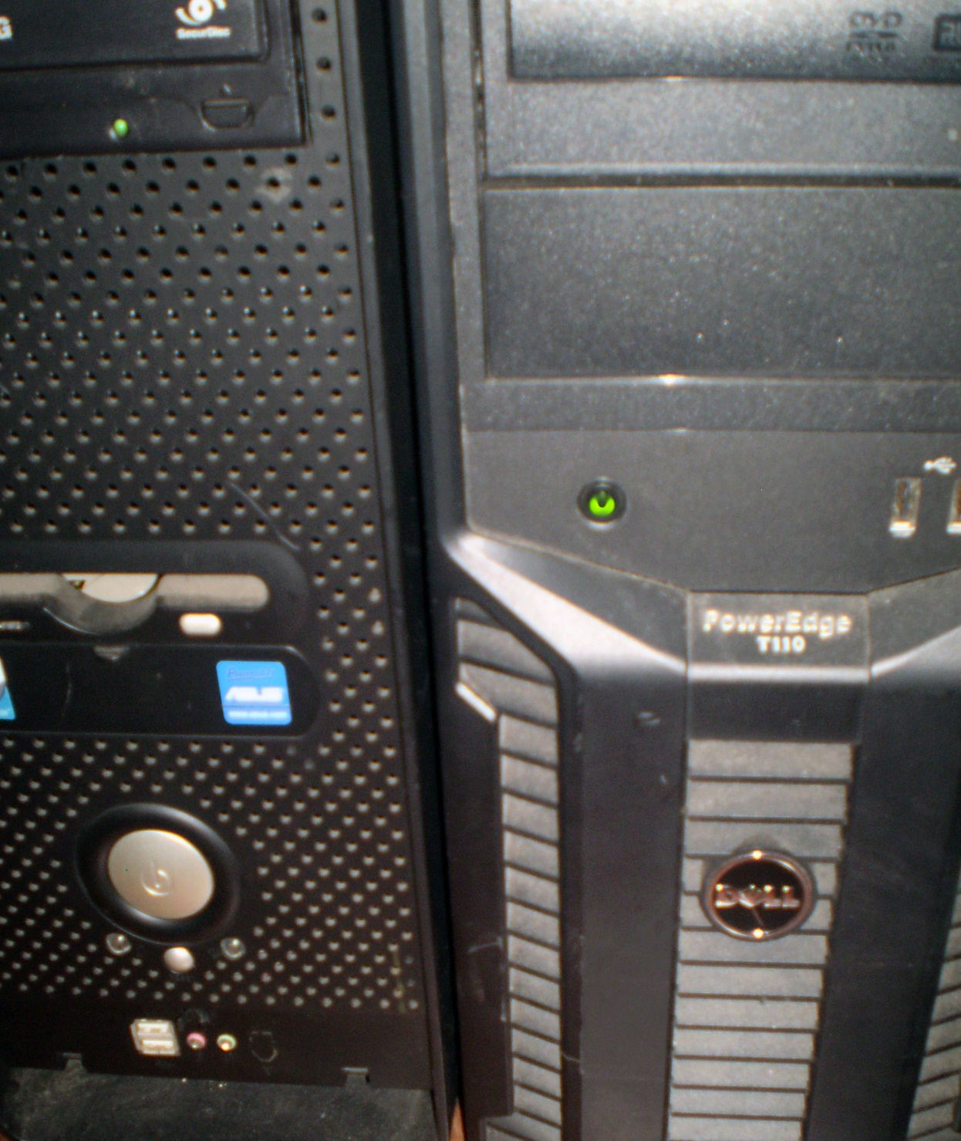

*No Payment, no advertising*

Please, if you want to use it, just inform the source.

We are not charging you for this material, so, just

Let the others know who did it.

*You will learn for real*

We will not hide any information, you will learn for real!

All content is virus free.

No piracy, use only original / licensed software.

**100% Free**

*Network Roadmap:*

*The path to Master in Network Security*

*01 – Network Basics*

*02 – Network Intermediate*

*03 – Network Advanced*

*04 –Information Security Concepts*

*05 – Hacking (level 01, 02 and 03)*

*06 – Ethical Hacking*

*07 – Information Security Audits*

*08 – Related Law (information technology)*

Use this material at your own risk.

Since we do not sell it, we do not provide of support.

My personal contact is only for questions related to the courses.

Valter Leite  
Trainer

Twitter: @valtermbleite

e-mail: valterl@hotmail.com

Liquidação até 17/03/11

Horário da loja:

10:00 às 17:00 (seg a sex)

9:00 às 18:00 (Sáb e Dom)

**Pedro Ruivo**  
**Artes**

Rua principal 98765

Savannah, GA 98031

Localizada em Harrington no lado oposto do Estacionamento Memorial